Network segmentation

Network segmentation video

.

Broadcast domains and segmentation

**In an ethernet LAN**, devices use broadcasts and the address resolution protocol (ARP) to locate other devices

**ARP sends Layer 2 broadcasts to a known IPv4 address on the local network to discover the associated MAC address**

**Devices on ethernet LANs also locate other devices using services**

A host typically acquires its IPv4 address configuration using the dynamic host configuration protocol (DHCP) which sends broadcasts on the local network to locate a DHCP server

Switches propagate broadcasts out all interfaces expect the interface on which it was received

Routers do not propagate broadcasts

Problems with large broadcast domains

Is that these hosts can generate excessive broadcasts and negatively affect the network

And it can result in   
 slow network operations due to the significant amount of traffic it can cause, and slow device operations because a device must accept and process each broadcast packet

The solution is to reduce the size of the network to create smaller broadcast domains in a process called subnetting

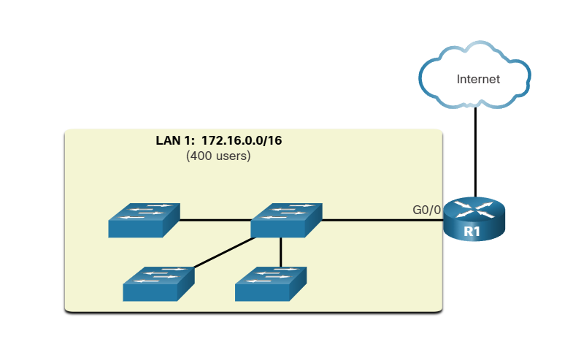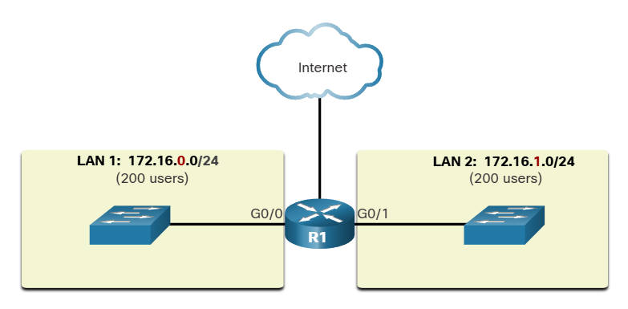

Reasons for segmenting networks

Subnetting reduces overall network traffic and improves network performance

It also enables an administrator to implement security policies such as which subnets are allowed or not allowed to communicate together

Also it reduces the number of devices affected by abnormal broadcast traffic

LOCATION GROUP OF FUNCTIONS DEVICE TYPE

